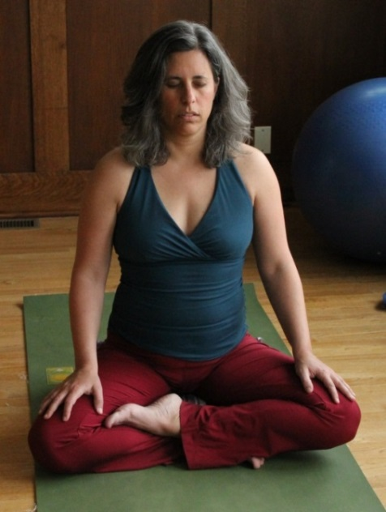
Meditation with Julie Harris

Cultivate the Power
of Your Mind This Spring

One Sunday a month from 2:30 to 3:45 pm, following Restorative Yoga
(First Sunday class on March 22 is FREE!)

Every Tuesday from 8:00 to 9:15 am, starting March 31

at Yoga Montclair, 107 Forest Avenue

Meditation in the tantric tradition is about being able to shift your perspective, so that you can learn to see and respect the power inside you and all around you. Practicing in community helps to cultivate both of these aspects.

Whether you’re new to meditation or would like to deepen your existing practice, this class will provide you with a space to:

- Practice simple asanas that open the hips and make sitting more comfortable (appropriate for all levels)
- Explore different types of meditation, including breath-centered, mantra, walking meditation; open eyes and closed eyes
- Discuss ways to create a regular practice, what’s working for you, and what’s getting in your way
- Get support from a community of meditators

Come every week, or drop in for a boost of meditative community anytime!

