Warrior Vinyasa

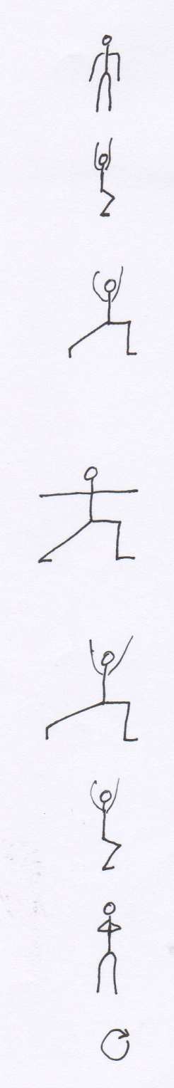
Tadasana (Mountain pose). Start standing in tadasana, with your feet hip width apart and parallel. Connect with the sensation of your feet on the floor, feeling your connection to the ground. Stay here for 3 breaths.

Utkatasana (Chair pose). On an inhale, lift your arms straight up over your head and bend your knees as if you are sitting in a chair. Pull your belly in and up to support your back. Stay here for 3 breaths.

High lunge. On an exhale, keep your arms overhead and step your right foot back into a high lunge. Feel your feet on the ground and squeeze your thighs toward each other to stabilize yourself. 3 breaths.

Warrior II. On an exhale, ground your right heel down so that your right foot is parallel to the back of your mat, and your left heel bisects your right arch. At the same time, push your arms down so that they are out in a “T” position, palms face down. Be sure that your legs are wide enough – a good measure is that your ankles should be underneath your wrists. Bend your front knee deeply. 3 breaths.

High lunge. On an inhale, transition back to a high lunge over your left leg by lifting the arms overhead and pivoting both feet to face the front of the mat. Bend the front knee deeply. 3 breaths.

Utkatasana. On an exhale, step your right foot forward to meet your left foot in chair pose. Knees bent, arms overhead. Belly in and up. 3 breaths.

Tadasana. On an exhale, straighten your legs, bring your hands to prayer position in front of your heart. Feel your feet on the ground again. 3 breaths.

Repeat on the other side.

